REAL ESTATE PROJECT: PHASE 1
Create Your Logo

For this project, you must have your own unique identity in the form of a corporate logo. You must design the logo in Microsoft Publisher using text and graphics. It should be roughly 1.5” tall and 3” wide (can be a little bigger, if necessary). No more than three colors total (including black). Examples of real estate logos are:

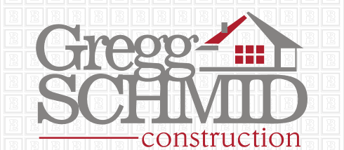
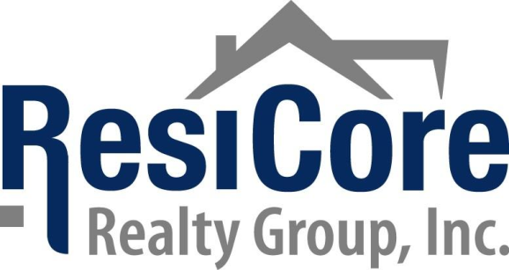
REAL ESTATE PROJECT: PHASE 1
Create Your Logo Scoring Guide

Be sure your logo includes all requirements. Your logo must be scored and acceptable before you can begin the rest of the project. Print your logo on a page by itself for scoring.

Pick an original name for your company:____________________________________________________

Sketch out two or three potential designs below:

Requirement | Points Possible | Deductions
Custom page size—3” or so wide and 1.5” or so tall | 5
Logo includes no more than 3 colors.  List the colors here: _____________  ________________ __________________ | 9
Logo items go with the theme—real estate and photographs are high quality | 6
Font selection is bold and eye catching.  List font(s) here: ________________  ____________________ ___________________ | 5
Logo uses layering, text effects, shape styles, and advanced features to make it look “better” than normal | 5
Printed in color; when printing, under SETUP at left, go to Page Position and set to centered | 5
Save in your Real Estate folder so you can use it in your future documents! | ---
 | 35
Name:_____________________________________

Instructor Notes:
___Revise and Resubmit before continuing
___Revise and re-export (teacher approval not required)
___Looks good! Continue on!
Staple printout to this sheet
REAL ESTATE PROJECT: PHASE 2
Create a Listing Flyer
Sample Real Estate Flyers

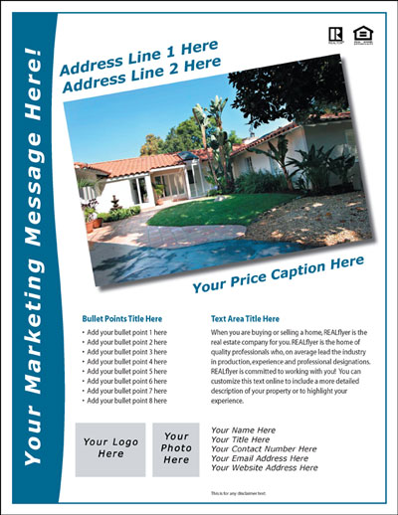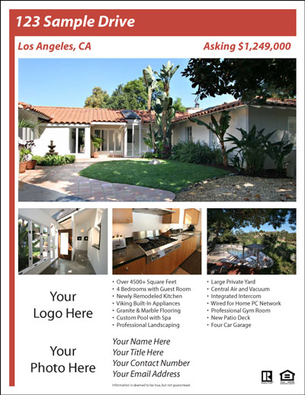

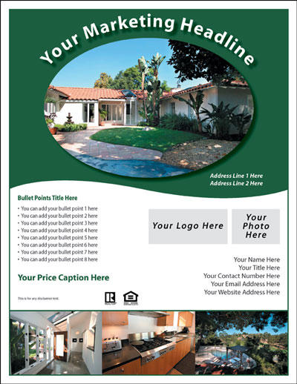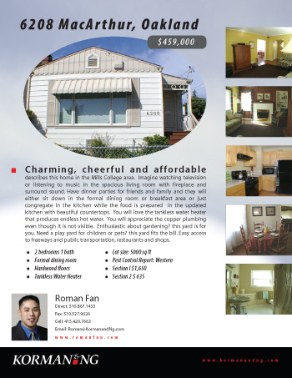
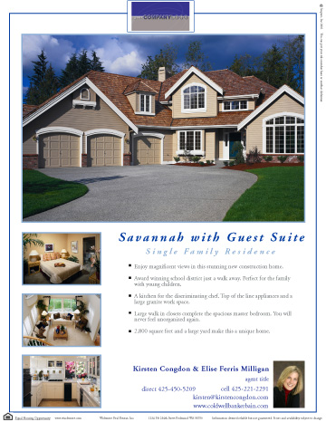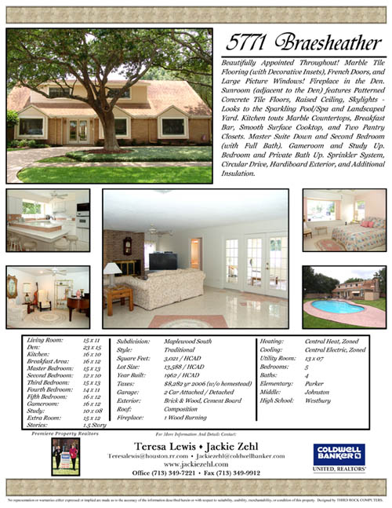
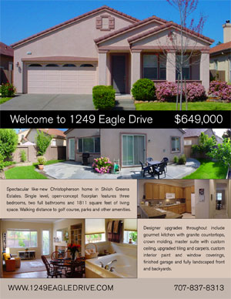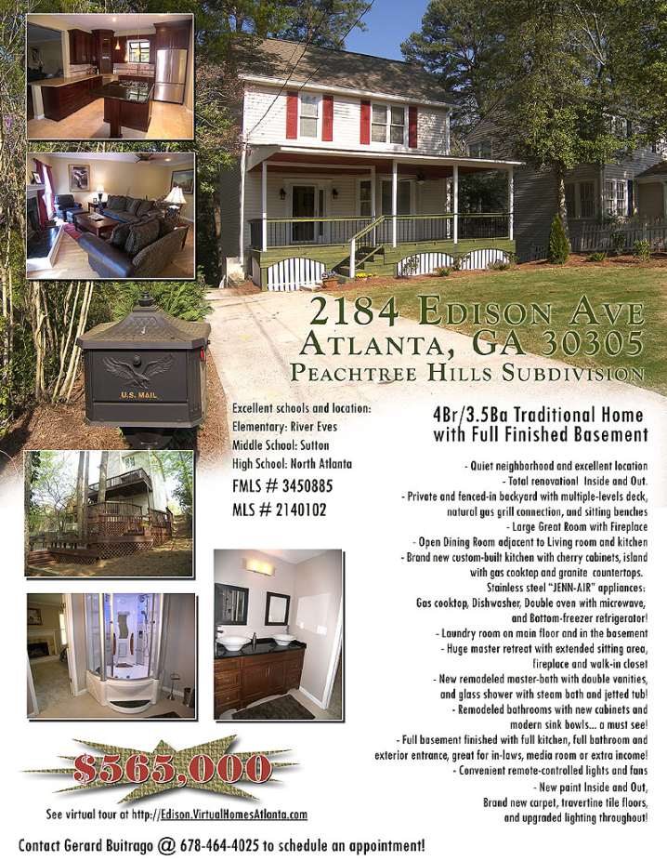
REAL ESTATE PROJECT: PHASE 2
Create a Listing Flyer Scoring Guide

Requirement | Points Possible | Deductions
Setup is on regular letter (8.5 x 11) OR legal (8.5 x 14) paper (your choice) and is 2 pages long | 5
Logo is included | 5
Contact information is included  (remember, you are the real estate agent!) | 5
Font selection is appropriate for theme and eye catching where necessary (highlight features!)  List font(s) here: ________________  ____________________ ___________________ | 5
Student uses layering, borders, quality graphic images, rotation, or other features to make the flyer appealing | 20
Spelling/grammar and salesmanship (ad talk)  Make me want this house! | 20
Printed in color and submitted on time | 5
Print b/w copy (it will not be front/back) and label all advanced features used (draw and identify) | 15
Overall professionalism: Includes proper inclusion of information, photo selection, and design | 10
Constructed response question  (type or write and attach to printout)  How do you feel your flyer will attract customers? Explain how and why you selected your font and color options. What do you feel looks best on your flyer and what could still use improvement? | 10
TOTAL POINTS | 100
Name:_____________________________________

Instructor Notes:

Staple b/w printout to this sheet!
Color printout should be turned in separately.
Do not write your name on the color printout; your contact information and logo should already be on the flyer!!!
REAL ESTATE PROJECT: PHASE 3
Create Your Business Card

Business Card Samples

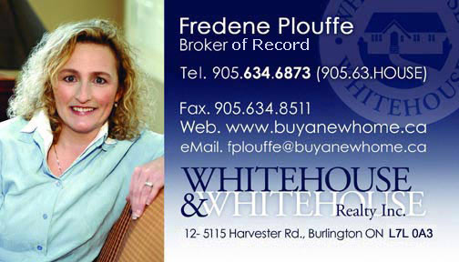
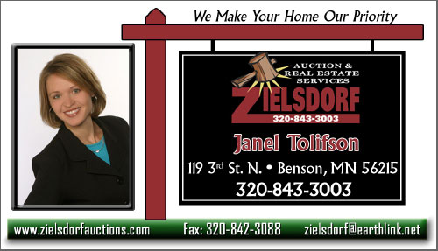
REAL ESTATE PROJECT: PHASE 3
Create Your Business Card Scoring Guide

Visit this website for innovative ideas: http://www.will-harris.com/design/biz-cards.htm

Requirement | Points Possible | Deductions
Custom Page Setup 1.75” x 3.25” | 5
Logo is included | 5
Pertinent information is included  (remember, you are the real estate agent!)  - Company name and address  - Contact name  - Phone numbers  - Fax numbers  - E-mail address  - Slogan  - Product or Services | 5
Font selection is appropriate for theme, clear to read, matches overall theme, is professional and eye catching  List font(s) here: ________________  ____________________ ___________________ | 5
Use of personal photo (business dress!) layered to fit seamlessly onto card | 10
Spelling/grammar | 10
Save and Print in color | 5
Constructed response question  (type or write and attach to printout)  Visit this site--http://www.empower-yourself-with-color-psychology.com/color-meanings-in-business.html  Identify how your business card color choice will affect your customers. Would you have selected different colors had you known this symbolism? Why or why not? | 10
Overall professionalism | 10
TOTAL POINTS | 65
Name:_____________________________________

Instructor Notes:
Cape Coral Home Listing Information Sheet
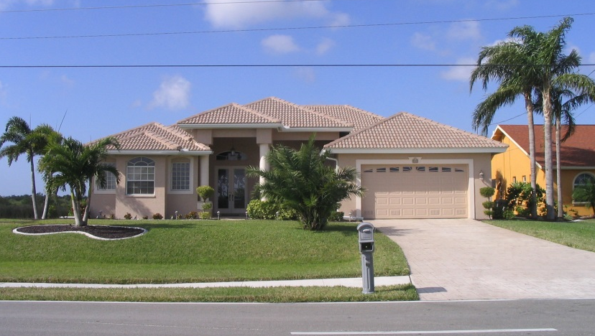
Listing #: 2257
PROPERTY LOCATION
Address: 1000 Riverfront Drive
Zip Code: 33914
State: Florida
City: SW Cape Coral

GENERAL INFORMATION
Price (in $): 635,000
Property type: Single Family
Bedrooms: 4
Baths: 3

PROPERTY DESCRIPTION

Exquisitely designed Luxury Gulf Access Home situated on 150 Ft. Wide canal in desirable SW Cape Coral. Immaculate custom built home has almost 3,000 sf. under air, and almost 5,000 sf in total. 4 bedrooms, 3 bathrooms, family room, great room and dining room. Double tray ceilings up to14 ft. in height, built-in entertainment center, fire place, large master suite w/walk in closet, Jacuzzi tub, walk in shower and bidet. Interior features also include granite countertops, tumbled marble and travertine stone floors, custom wood cabinets, gourmet kitchen with top of the line stainless steel appliances, huge breakfast bar area, and arched windows in every room. This dream home also features tile roof, paved driveway and walkways, 2 car garage, beautiful waterfront views across screened oversized lanai and pool deck with heated pool and spa. Very good neighborhood, the latest houses sold in this area are around 1 Million. Excellent investment and good house to live in!

PROPERTY DETAILS
Square feet: 2940
Number of Floors: 1
Age of Home: 3
# Family Room
# Dining Room
# Main Floor Bedroom
# Main Floor Bathroom
Walk-in Closets: 2
Laundry: Separate Room

KITCHEN
# Eat-in
# Large
# Snack Bar
# Pantry
# Ceramic Floor

BASEMENT
Basement: None

FIREPLACES
Fireplaces: 1
# Wood

APPLIANCES STAY
# Microwave
# Dishwasher
# Stove
# Washer
# Dryer

NEWER (0-5 years)
# Roof
# Gutters
# Carpeting
# Windows
# Appliances
# A/C
# Water Heater

FRESHLY PAINTED
# Interior
# Exterior

PARKING/GARAGE
Type: Garage Attached
Number of cars at garage: 2
# Insulated

OTHER PROPERTY DETAILS
# Spa/Jacuzzi
# Swimming Pool
# Whirlpool
# Central Air
# Security
# Wheelchair Accessible
# Cable

LOT DETAILS
# Sprinkler System

VIEW
# Waterfront

CLOSE TO
# Schools
# Shopping
# Town

COMMUNITY DETAILS
# Playground/Park
# Public Transportation
# Swimming Pool
# Tennis Courts
# Fitness Center
# Boating
# Sports Complex
# Nature/Bike Paths

Info about Cape Coral:
http://www.capecoral.com/

