Desktop Publishing Portfolio Project: Cruise Ship Mania

Examples Sheet
Note that these examples do not necessarily meet the guidelines in your grade sheet. They are here for reference purposes so you can see what some of these things might look like (real publications). Follow your specific guidelines as you work on your projects.

Before starting this project, visit this website to see what a cruise is really like. It will help you get some perspective when creating your projects. And, it’s fun to read! http://www.cruisemates.com/articles/before/Kuki-Basics.cfm

Cruise Line Logos
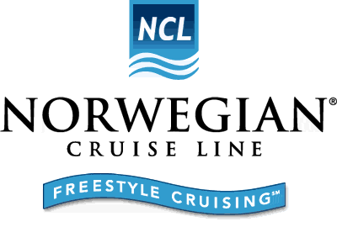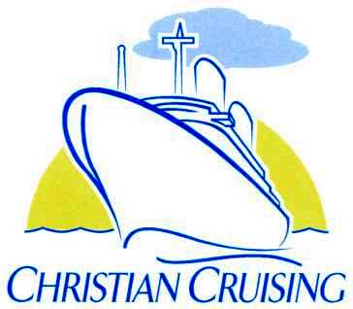

Cruise Ship Daily Newsletter
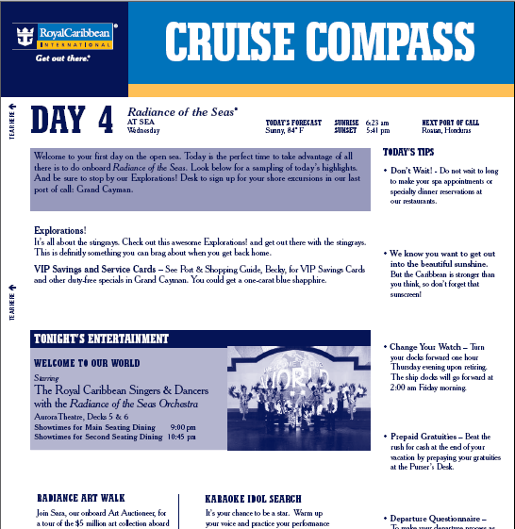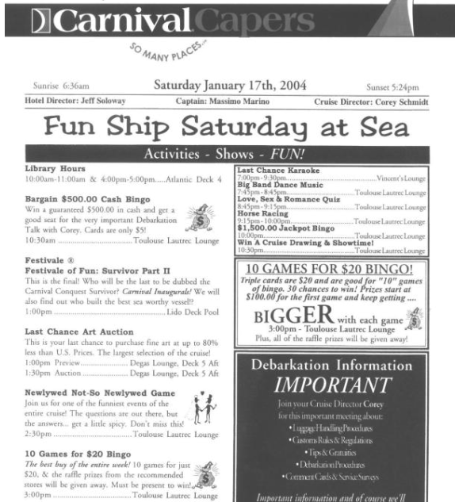
Real Examples Online: http://www.royalcaribbean.com/content/pdf/CruiseCompass.pdf
http://www.lifeiscruising.com/carnival_capers http://www.lifeiscruising.com/princess_patters

Cruise Card
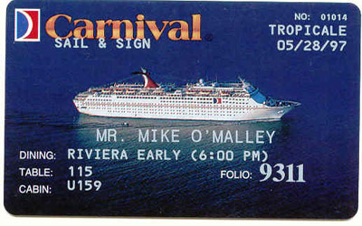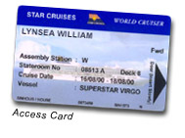

Door Hangers
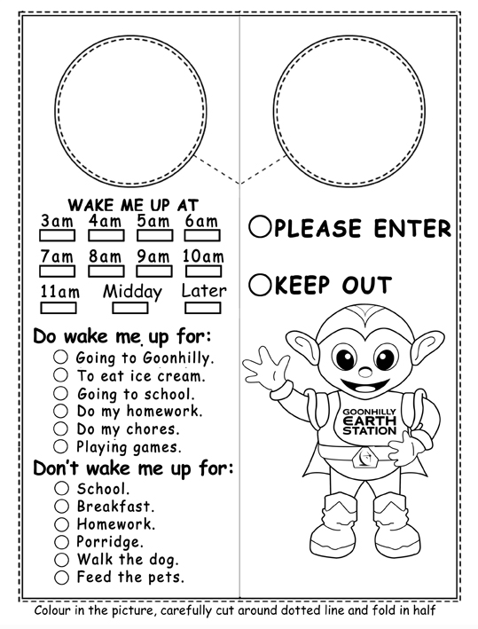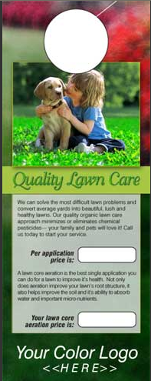
NOTES: 4” wide x 9” tall (0 margins, print centered in page; be sure to put “doorknob” on both sides. You will need to create 2 of these, one for the front and one for the back. Be sure to trim before submitting for a grade. You will include menu items on the door hanger. (see scoring guide)

Boarding Pass/ID Badge

 Barcode Site: http://www.barcodesinc.com/generator/index.php

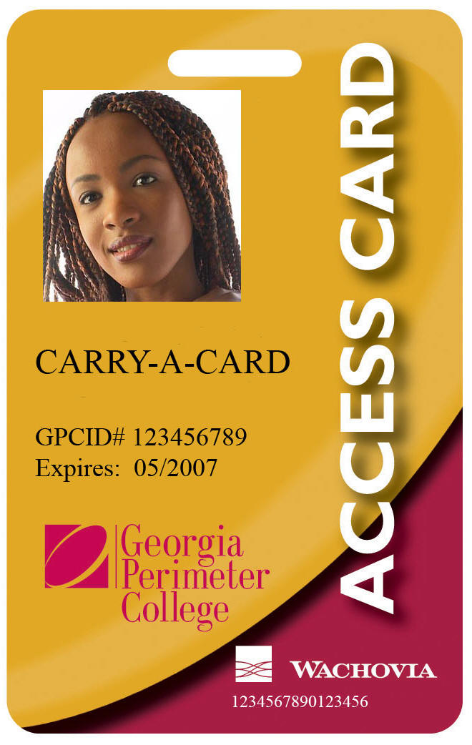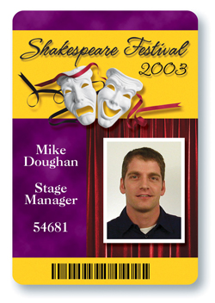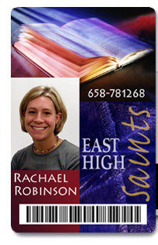

Custom Bingo Card
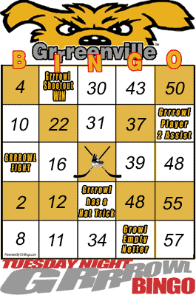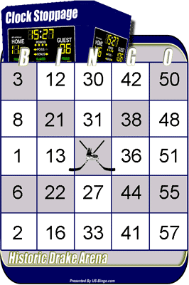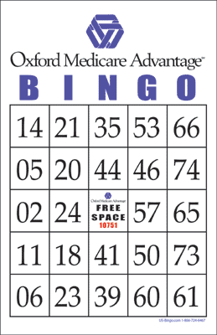

Table Tent
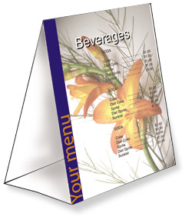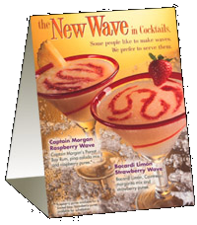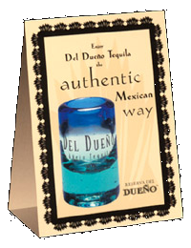
NOTES: Paper size: 3.75” wide by 11” tall; 0” margins
Guides: Set a ruler guide at 2 3/8” and 9 7/8” and do not place anything above the top guide or below the bottom guide. Set a ruler guide at 6 1/8” and that will separate the repeated panel. Display panels will be 3.75” tall; leave 2 3/8” (2.375) at the top for the base and 1 1/8” (1.125) at the bottom for the base. The top square panel will need to be flipped 180 degrees (upside-down); print on card stock. Only print on one side of the paper, and then fold the finished product to create the tent. See me for card stock when you are ready to print.

Names: _____________________

CRUISE DTP SCORING GUIDE/REQUIREMENTS
You must complete all projects listed on this page. Remember you are running a business and you should each decide on your role for the business. Divide work evenly but work together for an overall theme. Final copies due in binder with all items in plastic page covers and trimmed neatly.

*****Cruise Line Logo Requirements (DO NOT PRINT) | Points Possible | Deducted
Contains at least two colors | 2
Includes unique use of text (either reverse text, outlined, shadowed, etc.) | 5
Includes a shape or graphic that integrates seamlessly with the words | 5
Quality/professionalism | 8
Total Points | 20

*****Cruise Newsletter | Points Possible | Deducted
Contains logo | 2
2 total pages, printed front and back of one sheet of paper in portrait orientation (Print to student copier) | 5
Includes unique title (examples: Cruise Compass, Carnival Capers, Princess Patters) | 2
Includes borders and shading to break up the page | 5
Includes reverse text (light on dark) | 3
Includes basic information like captain (you), cruise director (a friend), date, sunrise/set time, destination(s) and things to do there, today’s activities/shows/entertainment, schedule, and assume this is for a day “at sea” and not at port (be sure to identify the deck name, lounge names, etc., for programming) | 15
Include a box with information about a ballroom dancing class or talent show | 5
Utilizes bullets OR leaders with text | 5
Uses three photographs and one quality clipart | 8
Quality/Creative/Grammar/Spelling Be creative, too! What would you want on a cruise? | 10
Total Points | 60

*****Sail and Sign/Room Key Card | Points Possible | Deducted
Contains logo | 2
Correct page size—credit card size (3.370” wide x2.125” tall) | 5
Includes appropriate photograph (ocean or ship) | 3
Includes basic information including name of cardholder, date of cruise, dining table # and assigned dining time, cabin number, and anything else you want to include | 5
Include a shape (triangle or arrow) showing which way to insert card into door | 3
Uses size 9 or smaller font for most text | 3
Uses appropriate and readable color scheme and clear, readable fonts | 4
Quality/Grammar/Spelling (and readability) | 5
Total Points | 30

*****Room Service Door Hanger | Points Possible | Deducted
Contains logo | 2
Correct page size—4” wide by 9” tall with a 2.75” circle near the top on both sides | 5
Includes appropriate photograph with meal theme (breakfast, lunch, dinner, or pizza) | 3
Side 1 includes nicely decorated front utilizing color, shading or shadows, and graphic | 6
Side 2 includes room number, at least 6 meal options and beverage options (do not include prices since cruises include meals at no additional charge) AND includes time frames for meal to be served (ranges of times in appropriate 30 minute increments) | 6
Uses either tables OR check boxes/glyphs (symbols) | 3
Quality/Grammar/Spelling | 5
Total Points | 30

*****Custom Bingo Card | Points Possible | Deducted
Contains logo | 2
Correct page size—bingo card size (4” wide x 5.5” tall) | 5
Uses a table in a square shape with numbers and free space, (3.5” x 3.5” table, 5 rows/5 columns, .7” squares); numbers are centered horizontally and vertically in the rows/columns | 6
Includes outlined BINGO heading | 4
Use of shading in pattern on grid | 5
Original free space contains an appropriate graphic | 3
Quality/Spelling/Originality | 5
Total Points | 30

*****Boarding Pass/ID badge | Points Possible | Deducted
Contains logo | 2
Correct page size—landscape (2.125 wide x 4.125 tall) | 5
Includes rotated text (BOARDING PASS) with a drop shadow (InDesign: Type, Create Outlines first) | 3
Includes personal barcode (use barcode website given with examples and create one with your last name) | 5
Includes a small head shot (of you) and general ID information (height, birthdate, state of residence, etc.) | 3
Uses size 9 or smaller font for most text | 3
Uses appropriate and readable color scheme and clear, readable fonts | 4
Quality/Grammar/Spelling (and readability) | 5
Total Points | 30

*****Table Tent | Points Possible | Deducted
Contains logo | 2
Correct page size—3.75” wide x 11” tall | 5
Information: Table tent has information about an upcoming program onboard (talent show, game night, formal night, midnight buffet, etc.) and includes time and location information | 3
Top panel is printed upside down (rotated 180 degrees); should match other panel (front and back of folded tent will be identical) | 3
Utilizes white feathered box(es) for information with opacity applied to background (somewhat transparent) and no stroke | 4
Use of color, fonts, and space | 5
Contains at least one appropriate graphic (other than logo) | 3
Quality/Spelling/Originality | 5
Total Points | 30

Total: __________ / 230

Comments:

